Kent Cycling Association



President: Mrs. Pat Hill

Open 25 Mile Time Trial

Promoted for and on behalf of Cycling Time Trials under their Rules and Regulations

Sunday 18th April 2021

|  |  |
| --- | --- |
| **Course:** Q25/8 | **Start:** 07.00 |

**Timekeepers:** Paul Mepham (V.C.Elan) and Christine Burrows (Thanet RC)

**Event HQ:** Chilham Village Hall, Chilham Castle Estate, Chilham, Canterbury CT4 8DB

Small Hall

**HQ open from 6 am.**

### Event Secretary: Pip Jenkins, 44 Friezlands Road, Tunbridge Wells, Kent TN4 8LJ.

### Tel: 07938558894 Email: pip.jenkins88@gmail.com

PLEASE TAKE NOTE OF THE FOLLOWING COVID 19 GUIDANCE.

SOCIAL DISTANCE RULES APPLY TO ALL RIDERS, HELPERS, MARSHALS AND TIME KEEPERS.

PLEASE BE RESPECTFUL AND KEEP US ALL-SAFE.

PLEASE DO NOT ATTEND THE EVENT IF YOU OR ANY MEMBER OF YOUR SUPPORT CREW OR FAMILY SHOWS SYSTEMS OF COVID 19 OR FEEL UNWELL.

**Course:** Challock – Canterbury – Ashford – Chilham

Start on A.252 east of Molash at corner post of Northdown House at entrance to

Shottenden Lane. (TR 032522). Proceed east on A.252 and A.28 to Milton Manor RAB

Thanington (6.726 miles). Turn and retrace (M) on A.28 via Chilham fork where bear

left (M) (Extreme Care) to A2070 Willesborough Rd. RAB (17.126 miles). (M) Retrace to

Chilham fork where left (M) to re-join A252. Proceed westwards to finish approx. 290

yards past Chilham Castle Keep entrance (TQ 063535).

**Course GPS - <https://www.strava.com/routes/2415812?hl=en-GB>**

**Course Records** M: Chris Fennell - 50.05 W: Emma Lewis – 53:53: Male (Junior) Lance Childs 55:03

Awards

|  |  |
| --- | --- |
| **TT Scratch** |  |
| 1st | Gilt Plated Medal |
| 2nd | Silver Plated Medal |
| 3rd | Bronze Medal |
|  |  |
| **Best improvement on previous 3 year PB** |  |
| 1st | Gilt Plated Medal |
| 2nd | Silver Plated Medal |
| 3rd | Bronze Medal |
|  |  |
| **Veteran on Standard** |  |
| 1st | Gilt Plated Medal |
| 2nd | Silver Plated Medal |
| 3rd | Bronze Medal |
|  |  |
| **Women** |  |
| 1st  2nd  3rd | Gilt Plated Medal  Silver Plated Medal  Bronze Medal |
| **Junior**  1st  2nd | Gilt Plated Medal  Silver Plated Medal |
|  |  |
| **Fastest Club Team of 3 Riders** | Bronze Medals |
|  |  |

|  |  |
| --- | --- |
| **Road Bike** |  |
| 1st | £15 Aerocoach voucher + Gilt Plated Medal |
| 2nd | Silver Plated Medal |
| 3rd | Bronze Medal |
|  |  |
| **Women** |  |
| 1st  2nd  3rd | £15 Aerocoach voucher + Gilt Plated Medal  Silver Plated Medal  Bronze Medal |
| **Junior**  1st  2nd | Gilt Plated Medal  Silver Plated Medal |

Information for competitors

The **Headquarters** is at Chilham Village Hall, Chilham Castle Estate, Chilham, Canterbury CT4 8DB (Small Hall)

**Numbers and signing on/out sheet will be at the HQ (NOT at the start). Signing on will be done outside. Please bring your own pen for signing and your own safety pins if needed. Please use provided sanitiser. After finishing and signing off please place your number in the bucket of disinfectant provided.**

**Masks to be worn when at HQ and no spectators allowed.**

Competitors must personally sign on and out at the HQ or they will not be allowed to race. Signing-on and out sheets and race numbers will be at the HQ. Failure to do will result in the competitor being recorded as DNF.

**Toilets – We will have the use of two toilets – The toilet is located in the passageway to the left of the kitchen. we will operate a one- way system please queue outside following social distancing measures. PLEASE come dressed ready to compete – do not use the toilet as a changing facility.**

Please keep the noise to a minimum to avoid unnecessary disturbance to the local residents.

There will be No results or prizes at the HQ, Please do not cognate after your race, and head home once your finished. Results will be on the CTT website after the event and prizes will be sent out.

**No rider to use a turbo trainer or rollers in the HQ parking area or adjacent roads that are within 50 metres of a domestic property. Anyone failing to comply with this restriction risks disqualification.**

Competitors or their helpers must not park in the vicinity of the start or finish. Under no circumstances should competitors approach the timekeeper.

**REAR LIGHTS No competitor shall be permitted to start either a Type A or Type B event unless such competitor has affixed to the rear of their machine a working rear red light, either flashing or constant, that is illuminated and in a position that is clearly visible to other road users.**

Covering the Course The onus of keeping to the course rests with each rider.

Awareness of Surroundings - Competitors must not use ANY audio equipment except prescribed hearing aids. Where head and/or eye protection is used, competitors must ensure that this does not impair their vision or hearing. N.B. A competitor in breach of this regulation shall be disqualified. N.B. Competitors must not use a mobile phone while mounted on their machine.

**Do not perform U-turns in the Start and Finishing area of the busy A252.**

**In the interests of your own safety Cycling Time Trials strongly advise you to wear a HARD SHELL HELMET** that meets an Internationally accepted safety standard. All competitors under the age of 18 and/or Juniors MUST wear a properly affixed helmet, which must be of hard/soft shell construction. Helmets should conform to a recognised Standard such as SNELL B95, ANSI Z90.4, AUS/NZS 2063:96, DIN 33-954, CPSC or EN 1078.

**Riders please beware of the regulation below – specifically Reg. 20 (a) which covers the issue of HEAD DOWN riding – Head down riding will not be tolerated.**

Regulation 20 of CTT’s Rules and Regulations (Observance of the Law) provides that:

20. Observance of the Law All competitors in, or in the vicinity of the event, must observe the law of the land relating to road use. In particular, but without prejudice to the general principles of this Regulation, competitors must:

* (a)  not ride in a manner that is unsafe either to themselves or to other road users;
* (b)  ride on the left-hand side of the road except for safe overtaking and when making right hand turns;
* (c)  conform to all traffic signs, signals and direction indicators;
* (d)  in making any turn before, during or after the event, ensure that it is safe to do so.

**Road Bike Regulations**

The aim of this series is to be as inclusive as possible, and so have as few restrictions on bikes as we can.

In general, we have found the following to be a good guide

**1. No aerobars, clip on aerobars or aero extensions can be used**

**2. Hands must be holding the handlebars at all times whilst racing (i.e. not with forearms resting on the handlebar)**

**3. Legs must only be covered to mid shin**

**4. Wheels may have no more than 90mm rim depth and must have at least 12 spokes**

**5. Helmets must have no visor**

**6. Ears must not be covered by the helmet (Giro Aerohead helmets are not permitted No aero TT helmets)**

**RIDERS BE AWARE:**

There are rough sections of road just after the start, on the descent of Molash Hill, also on the return leg on the A28 as you enter Chilham. Also there are potholes approximately 1 mile on the approach to the Canterbury turn and again approximately 2miles on the approach to the Ashford turn. The course is generally in good order but these areas need special care and riders should keep their heads up at all times to view the road ahead.

**HEADS UP AND RIDE SAFE.**

**Directions to the start:** Turn left from the HQ car park onto the A251 towards Head west for 2.4 miles on A252 towards Soles hill Rd. Follow road to the entrance to Shottenden Lane the start is on your right.

**Allow at least 15 -20 minutes to ride to the start point it is 2.4 miles up hill. Please remember to social distance at the start. Queuing 2 meters apart and not congregating.**

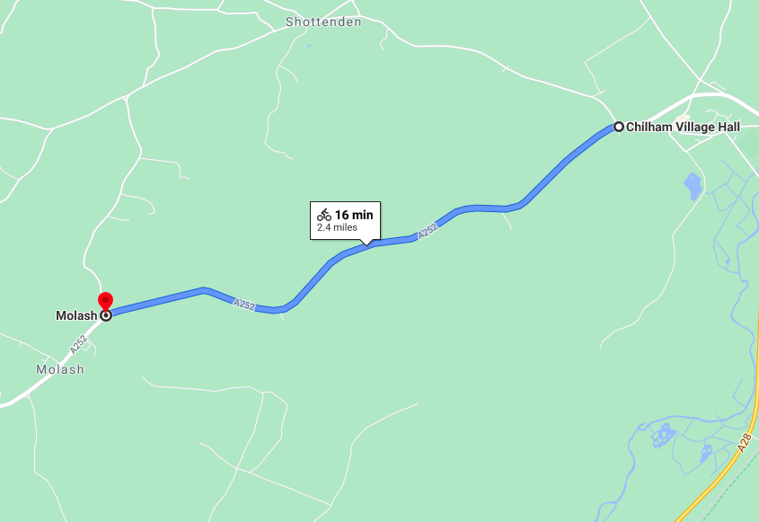

HQ CT4 8DB

START